
Evaluating the Development Models of Two Programming Languages

Launching into Computing

Dr. Samuel Danso
18 October 2025
Contents
Table of Figures 2
Introduction 3
Development Models 3
Syntax and Readability 5
Performance Efficiency 5
Scalability and Maintainability 6
Security Implications 7
Real-World Applicability 8
Conclusion 9
References 10
Appendices 13
Appendix A – Python Code for File Encryption and Decryption 13
Appendix A – Python Code for File Encryption and Decryption(Continued) 14
Appendix B - Python Code and test.txt file’s Directory – Jupyter Notebook hosted by Anaconda Navigator 15
Appendix C - Test the Python Utility 16
Appendix C – Continued - Python Faster Execution (4th Run) 17
Appendix C – Continued - Python Faster Execution (5th Run) 18
Appendix D – Java Codes for File Encryption and Decryption 19
Appendix D – Continued Java Encryption, and Decryption Utility 20
Appendix E – Troubleshooting Screenshots - Compile the Java. 20
Appendix F – Continued Troubleshooting Screenshots – Runing the Java 22
Appendix F – Continued troubleshooting – Installing Hex Editor 23
Appendix F – Continued Troubleshooting Nanoseconds 25
Appendix F – Continued Troubleshooting Nanoseconds 26
Appendix G – Java Compiled and Executed – First Time 27
Appendix G - Continued – Java Faster Execution (4th Run) 28
Appendix H – Development Processes and Troubleshooting Table 29
Appendix I – Runtime Comparison Table: Python vs Java AES Utility 29

Table of Figures

Figure 1: Screenshot of comparative development processes for Python and Java utilities, originally presented in Appendix H. 4
Figure 2 Runtime Comparison Table, originally presented in Appendix I 6

Introduction

This report will compare two programming languages, consisting of Python and Java, through the development of a file encryption utility using the AES algorithm. The goal of this report is to compare these languages over five dimensions as follows: development models, syntax and readability, performance efficiency, scalability, and maintainability, and finally security implications.

Development Models

Python supports procedural, functional, and object-orientated programming (OOP). For this utility (Appendix A), a procedural model was used, allowing functions to be executed sequentially within a Jupyter Notebook (Appendix B). This model is well-suited to rapid prototyping and educational contexts (Kilaru, 2024).
Conversely, Java is an OOP language, and even a simple encryption and decryption file utility (Appendix D) must be encapsulated inside a class hierarchy. There is only one class in the Java version (FileEncryptor) included with static methods. This method enhances modularity, which is aligned with Java’s design philosophy. However, it also adds more repetitive code (Overflow, 2023).
Python is dynamically typed and interpreted, allowing developers to quickly experiment
with innovative ideas and make prototypes due to its flexibility and minimal setup (Appendix A). Java setup, on the other hand, is statically typed and compiled, which enforces stricter rules and more boilerplate code. Such restrictions can make Java setup and execution initially longer (Appendix I) but make the code more stable and easier to maintain in the long term (Gupta, 2022; Cutting, 2022; Alaria et al., 2023).
The figure 1 below illustrates a comparative development process for Python and Java, including issues and troubleshooting notes; the issues and troubleshooting screenshots are demonstrated in Appendix F.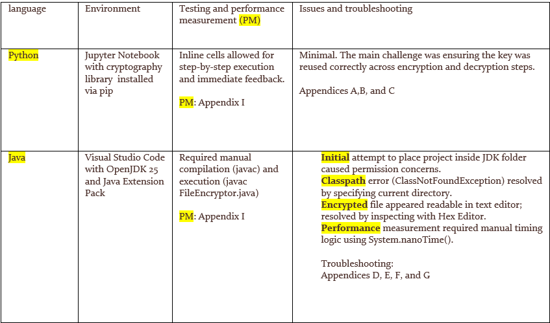
Figure 1: Screenshot of comparative development processes for Python and Java utilities, originally presented in Appendix H.

Syntax and Readability

Python is widely complimented for its readable and concise syntax (Appendix A). The encryption utility necessitated fewer lines of code and low structural overhead. The functions decrypt_file() and decrypt_file() were user-friendly, and the cryptography library simplified key management and file processing (Kilaru, 2024).
However, Java syntax (Appendix D) is more verbose. The same functionality requires detailed declarations, class-level organising, and exception management. For instance, reading and writing a file involved multiple steps using Files.readAllBytes() and Paths.get(). Despite the code being well-commented and organised, the cognitive load for a new developer is higher in Java due to its stringent type and structural requirements (AES-Python, 2024).
Notwithstanding this, Java’s verbosity can be beneficial in large-scale systems and new systems where clarity and type safety are paramount. Python’s minimalism, while elegant, may conceal underlying complexity in more sophisticated applications.

Performance Efficiency

Performance was measured by calculating the time of encryption and decryption operations using the %time command for Python, and System.nanoTime() method in Java, as there is no built-in stopwatch in Java. The faster execution times after the first few executions of both utilities () can be explained by runtime initialisation and optimisation effects (Appendices C and G).

Both utilities operated efficiently with smaller file sizes. Java took slightly longer to compile and run because of lower-level operations and JVM (Java Virtual Machine) overhead. Kilaru’s (2024) work demonstrates this perspective.
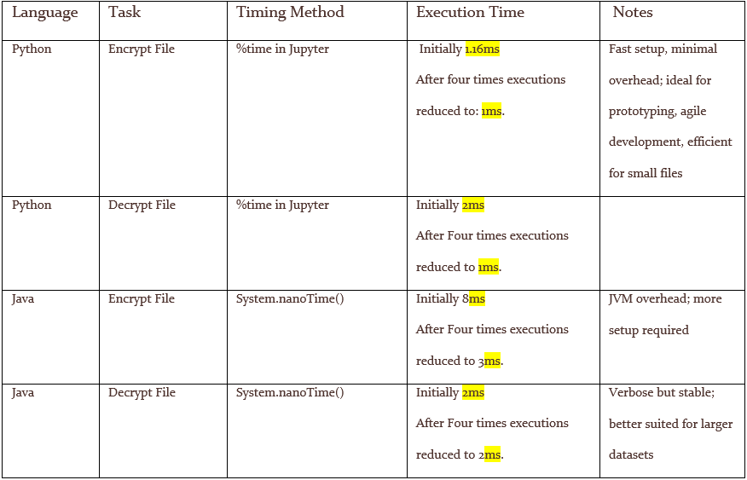
Figure 2 Runtime Comparison Table, originally presented in Appendix I

Scalability and Maintainability

AES-Python (2024) claims that due to dynamic typing and flexible syntax, Python is ideal for prototyping and agile development. However, in a larger project, Python’s lack of structure may make it harder to maintain up-to-date information.
In contrast, Java offers an object-orientated architecture and strong type, which make it easier to scale and maintain to keep the information up to date. The Java tool is harder to set up, but it is better for enterprise systems or projects with multiple developers (Stack Overflow, 2023).
Java, on the other hand, has an object-orientated architecture and a strong type, which make it easier to scale and keep the information up to date. The Java tool is harder to set up, but it is better for enterprise systems or projects with multiple developers (Stack Overflow, 2023).
I too found it challenging to set up and maintain the Java tool; however, this perspective may be biased because I have worked with Python more than Java.

Security Implications

Both utilities used the AES-128 algorithm, which is accepted for secure data handling. In Python, the cryptography library abstracts many security details, reducing the risk of implementation errors. Encryption, decryption, and key generation were managed through high-level APIs with built-in safeguards (Kilaru, 2024).
In Python, the Fernet module is imported from the cryptography library; it offers a comprehensive authenticated encryption system by combining AES-128 in CBC mode
with HMAC-SHA256 , so guaranteeing both confidentiality and integrity (two key elements of the CIA triad), which reduces the risk of misuse. Conversely, Java’s KeyGenerator securely generates random AES keys but does not mandate a secure cypher mode or authentication, so it leaves these essential elements to the developer. Consequently, Python Fernet is more secure by default, while Java necessitates additional methods, such as AES-GCM and secure key storage, to achieve comparable protection (Georges et al., 2007; Python Software Foundation, 2024; Oracle, 2025).
Stack Overflow (2023) claims that the Java security model relies heavily on manual configuration. Users must use the KeyGenerator, SecretKeySpec, and Cypher classes. While this method offers more control, it also elevates the risk of misconfiguration. For example, improper padding schemes or enciphering the Java modes may compromise security. Safe implementations can be provided by both languages; however, Java’s explicitness may be preferable in regulated environments where control and auditability are paramount.

Real-World Applicability

Kilaru (2024) claims that agile application development, automation, and data science primarily use Python. Python's ease of implementation and its comprehensive library make it ideal for prototyping and scripting.
Stack Overflow (2023) asserts that Android development, enterprise systems, and backend services extensively employ Java. Its robust performance characteristics and typing make it suitable for production-grade applications.
Python and Java are viable for real-world encryption tasks, with the choice depending on system requirements, team expertise, and context.

Conclusion

Python and Java utilities revealed distinct benefits and drawbacks. Python offered agile development, ease of use, readable syntax, and efficient performance for small tasks. Java provided scalability, structural integrity, and explicit security control.
The intended use case determines the choice. For experimentation and quick deployment, Python is ideal. However, Java is a reliable and robust solution for long-term, secure, and scalable systems.
This exercise not only deepened understanding of language-specific features but also highlighted the importance of environment setup, error handling, and performance evaluation in software development.

References

AES-Python. (2024). AES-Python · PyPI. Retrieved from https://pypi.org/project/AES-Python/
Alaria, S.K., Kaloriya, S. & Jain, S. (2023). Comparative Study of Java and Python: A Review. ResearchGate. Available at: https://www.researchgate.net/publication/376500120_Comparative_study_of_Java_and_Python_A_Review
Cutting, V. (2022). Comparative Review of JAVA and Python. International Journal of Research and Development in Applied Science and Engineering (IJRDASE). Available at: https://ijrdase.com/ijrdase/wp-content/uploads/2022/03/Comparative-Review-of-JAVA-and-Python.pdf
Evans, B.J. (2019). Java in a Nutshell: A Desktop Quick Reference. O’Reilly Media, Inc.
GeeksforGeeks. (2023). Difference between Procedural, Object-Oriented and Functional Programming. Retrieved from https://www.geeksforgeeks.org/difference-between-procedural-object-oriented-and-functional-programming/
Georges, A., Buytaert, D. and Eeckhout, L., 2007. Statistically rigorous Java performance evaluation. Proceedings of the 22nd Annual ACM SIGPLAN Conference on Object-Oriented Programming Systems and Applications (OOPSLA ’07). ACM, pp.57–76.
Gupta, A. (2022). Comparison in Java and Python: A Review Paper. International Journal of Innovative Research in Computer Science & Technology (IJIRCST), 10(2), pp.67–71. Available at: https://ijircst.org/DOC/13-comparison-in-java-and-python-a-review-paper.pdf
Hintikka, K. O., Wohlgemuth, S., & Bithas, A. (2017). Understanding the human side of information security management in organizations – A systematic literature review. Information and Computer Security, 25(4), 383-403.
Kilaru, J. (2024). A Comprehensive Guide to AES Encryption in Python. DEV Community. Retrieved from https://dev.to/jithendrasai_kilaru_1a67a/a-comprehensive-guide-to-aes-encryption-in-python-3i5l
Oracle, 2025. Java Platform, Standard Edition Performance Guide. Oracle Documentation. Available at: https://docs.oracle.com/javase/8/docs/technotes/guides/performance/ [Accessed 15 October 2025].
Oracle, 2025. Java Platform, Standard Edition Security Developer Guide. Oracle Documentation. Available at: https://docs.oracle.com/javase/8/docs/technotes/guides/security/ [Accessed 15 October 2025].
Oracle. (2024). Classes and Objects – The static Keyword. Oracle Java Documentation. Retrieved from https://docs.oracle.com/javase/tutorial/java/javaOO/classvars.html
Python Software Foundation, 2024. cryptography — Fernet (symmetric encryption). Python Documentation. Available at: https://cryptography.io/en/latest/fernet/ [Accessed 15 October 2025].
Python Software Foundation, 2024. time — Time access and conversions. Python 3.12 Documentation. Available at: https://docs.python.org/3/library/time.html [Accessed- 15 October 2025].
Stack Overflow. (2023). Encrypt and decrypt using PyCrypto AES-256. Retrieved from https://stackoverflow.com/questions/12524994/encrypt-and-decrypt-using-pycrypto-aes-256
Stallings, W. (2017) Cryptography and Network Security: Principles and Practice. Pearson Education India.
Vaudenay, S. (2002) ‘Security Flaws Induced by CBC Padding - Applications to SSL, IPSEC, WTLS ...’, in Advances in Cryptology - EUROCRYPT 2002 (Springer, Berlin, Heidelberg), pp. 534-546. Available at: https://link.springer.com/chapter/10.1007/3-540-46035-7_35 (Accessed: 15 October 2025).

Appendices

Appendix A – Python Code for File Encryption and Decryption

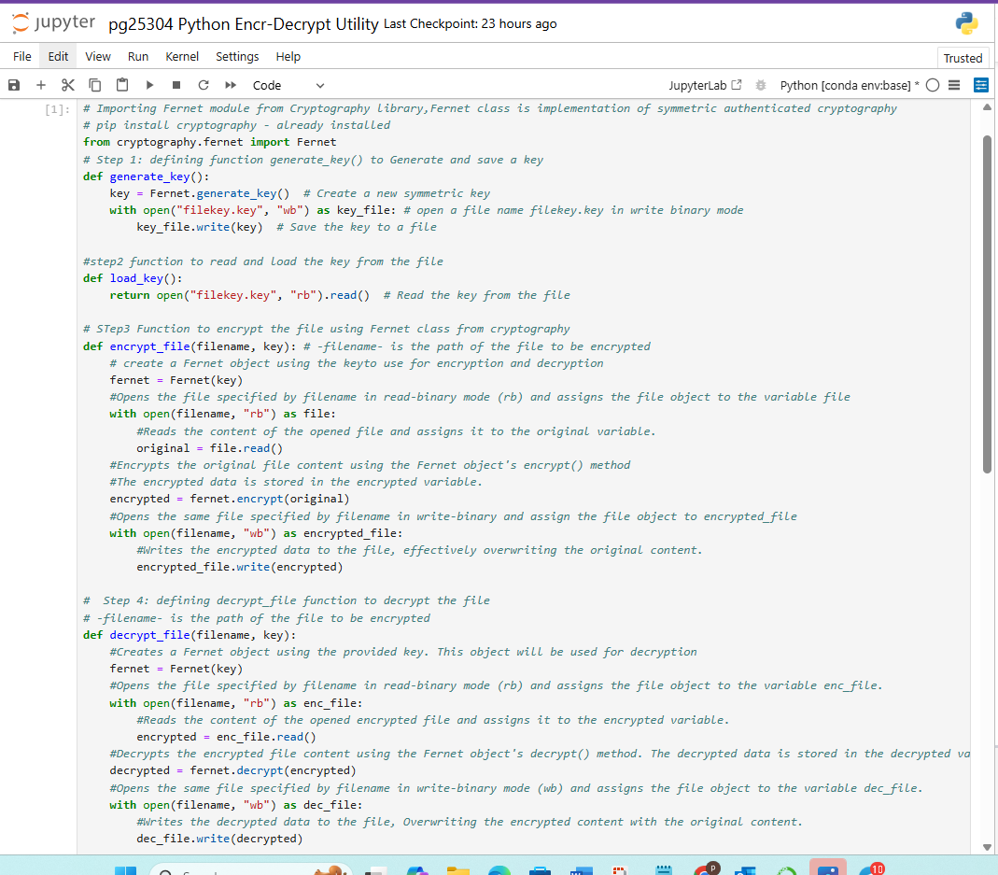

Appendix A – Python Code for File Encryption and Decryption(Continued)

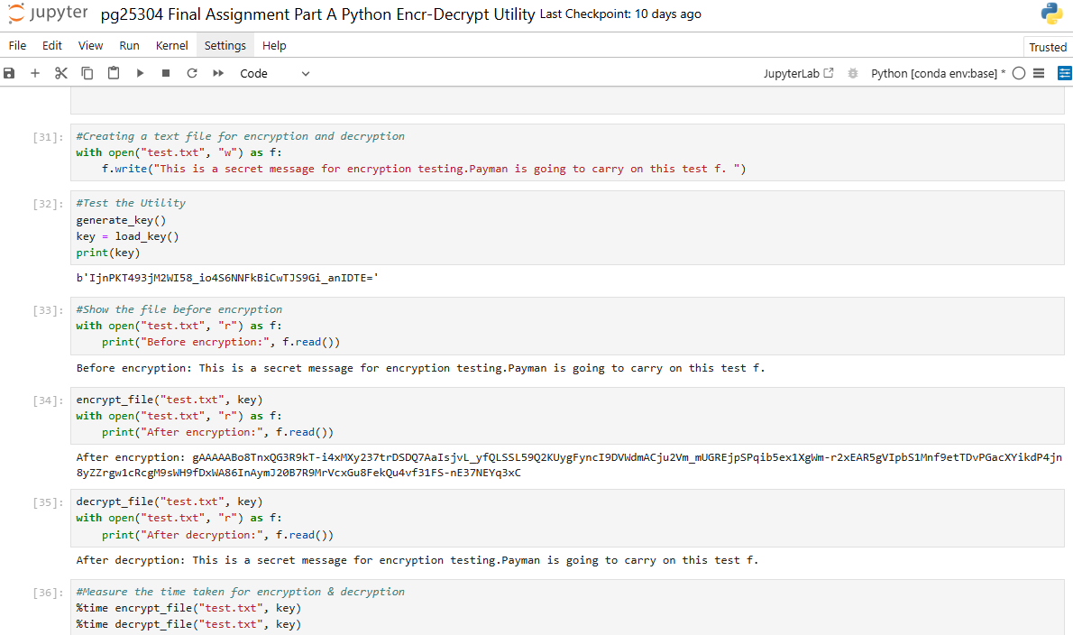

Appendix B - Test.txt file for Encryption on same directory of Python utility

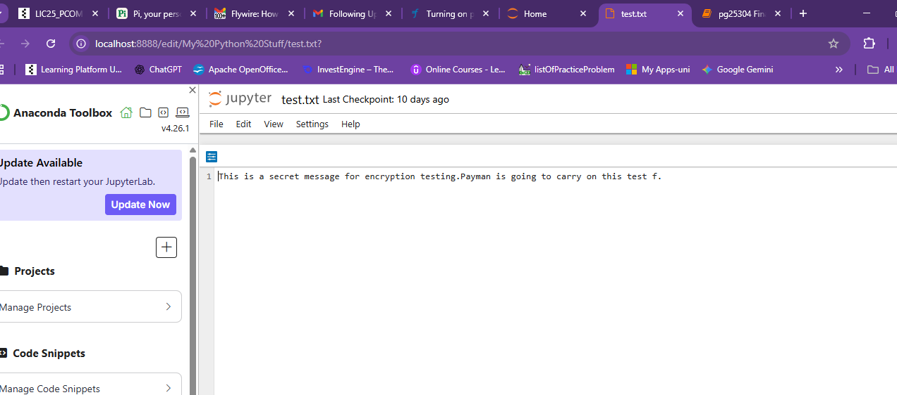

Appendix B - Python Code and test.txt file’s Directory – Jupyter Notebook hosted by Anaconda Navigator

I used Jupiter Notebook from Anaconda Navigator platform. For Python language exercise and creating of the Python utility.
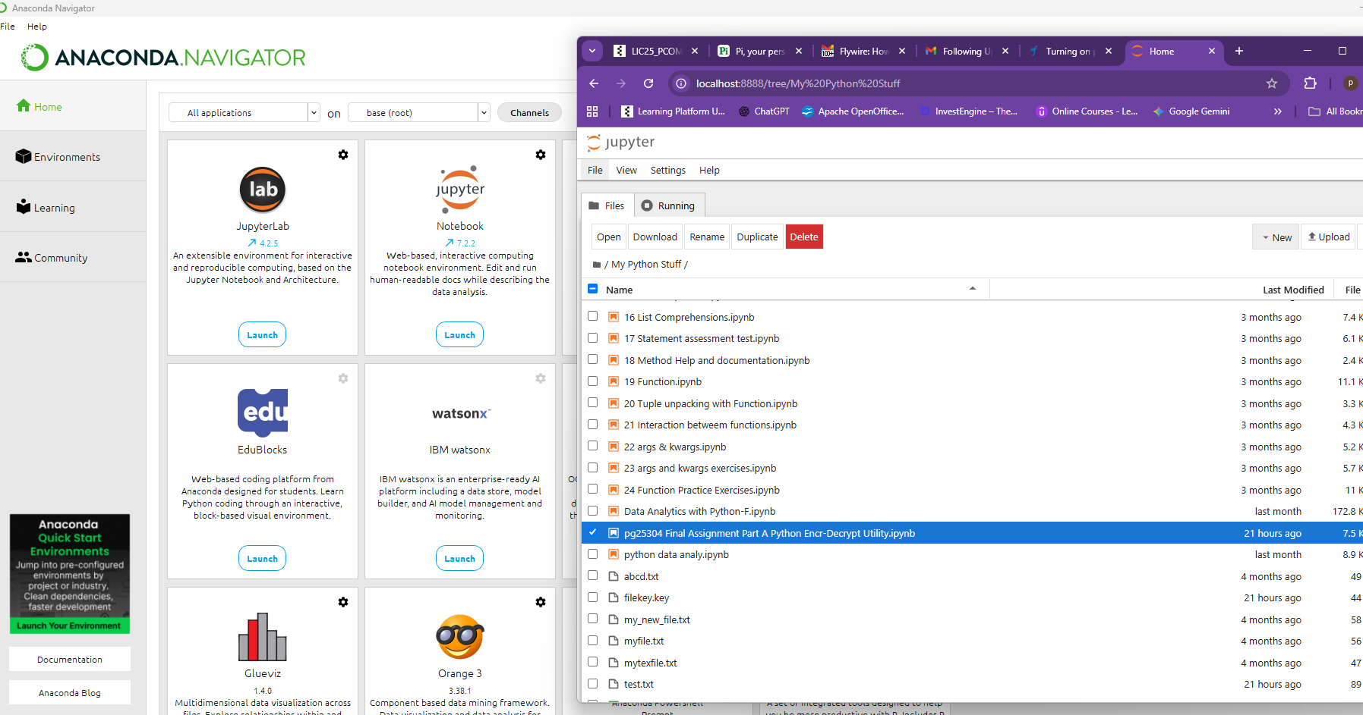

Appendix C - Test the Python Utility

Generate and load the key.
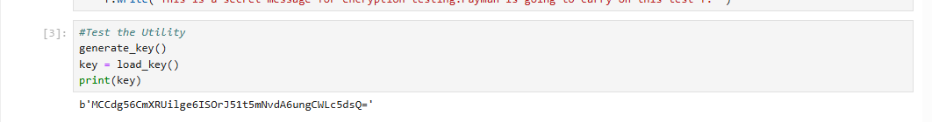
File before encryption.
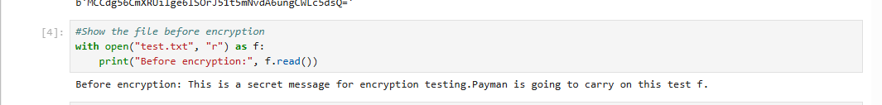
File after encryption
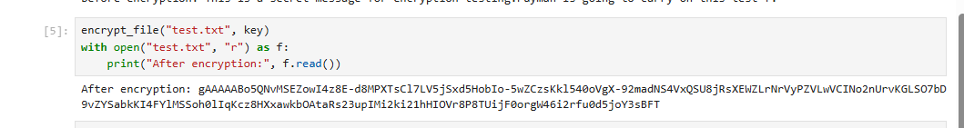
Decryption of the file
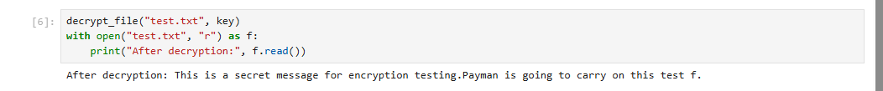
Measure performance
CPU times was 2.5 ms which reduced to (0 ns) after second execution.
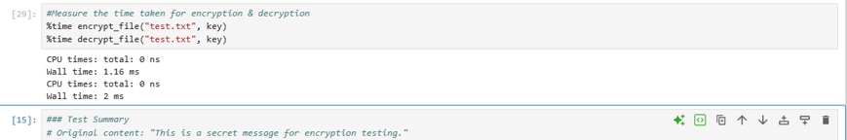

Appendix C – Continued - Python Faster Execution (4th Run)

In Python, the difference between CPU time (active processor work) and wall time (elapsed real time) is due to both the interpreter's overhead and the operating system's scheduling. Later runs benefit from cached imports and libraries that have already been set up. This warming-up effect is well-known in performance benchmarking literature, which says to throw away early iterations to get a steady-state performance measurement (see Georges et al., Statistically Rigorous Java Performance Evaluation, OOPSLA 2007).
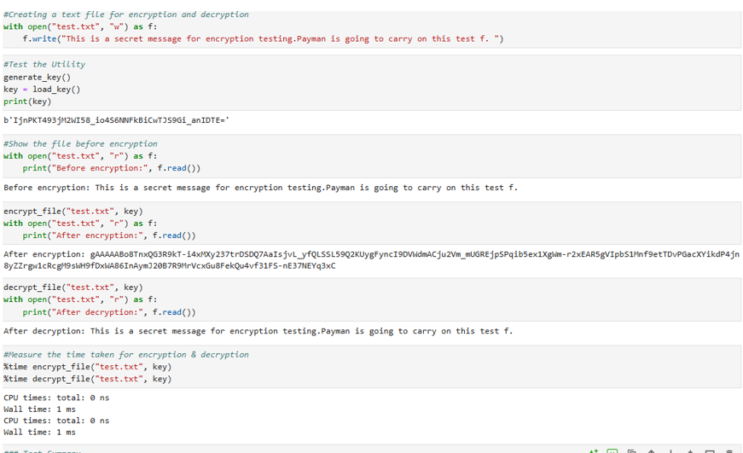

Appendix C – Continued - Python Faster Execution (5th Run)

Last Execution the time of encryption reduced to Microseconds after 6 times executions
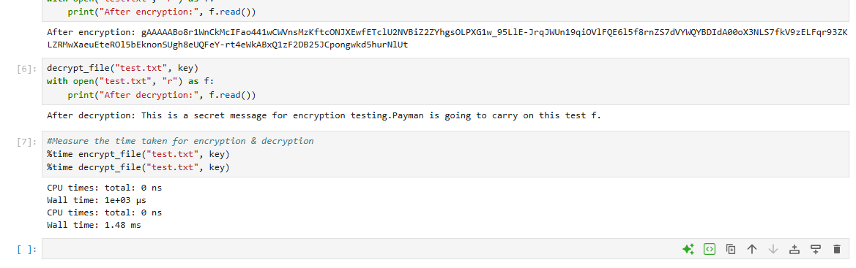

Appendix D – Java Codes for File Encryption and Decryption

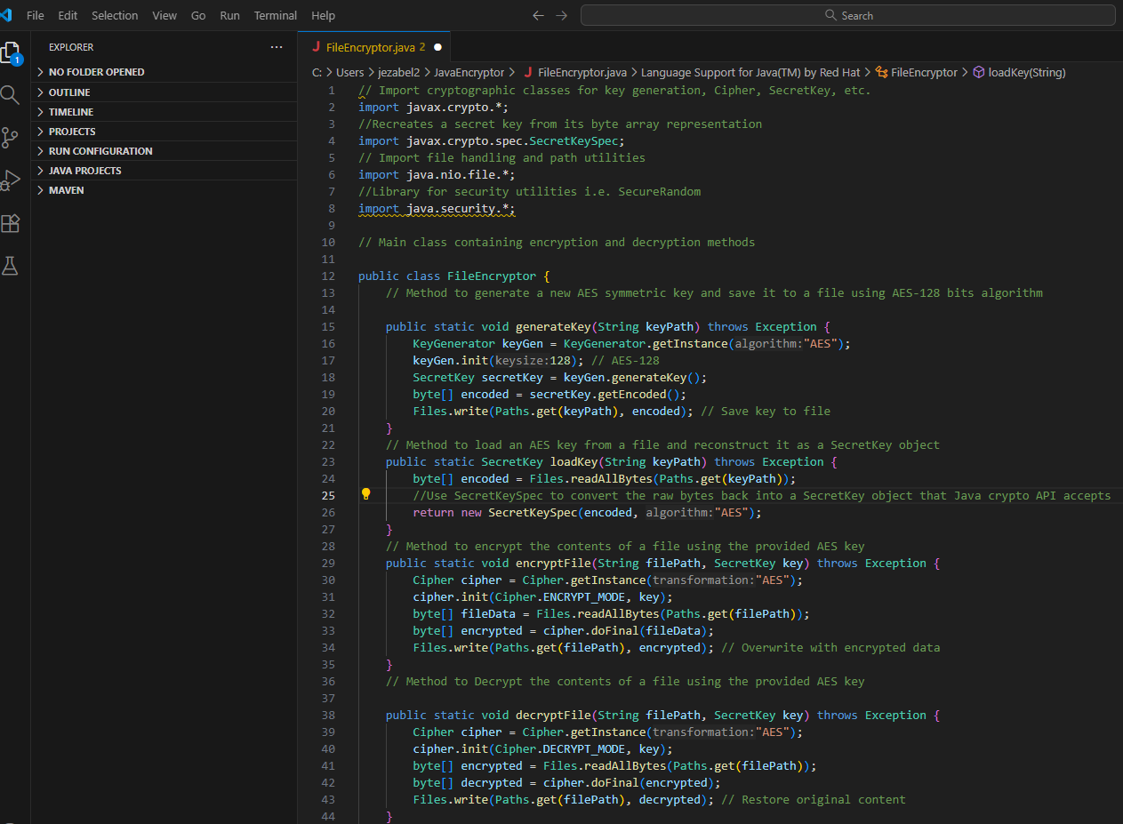

Appendix D – Continued Java Encryption, and Decryption Utility

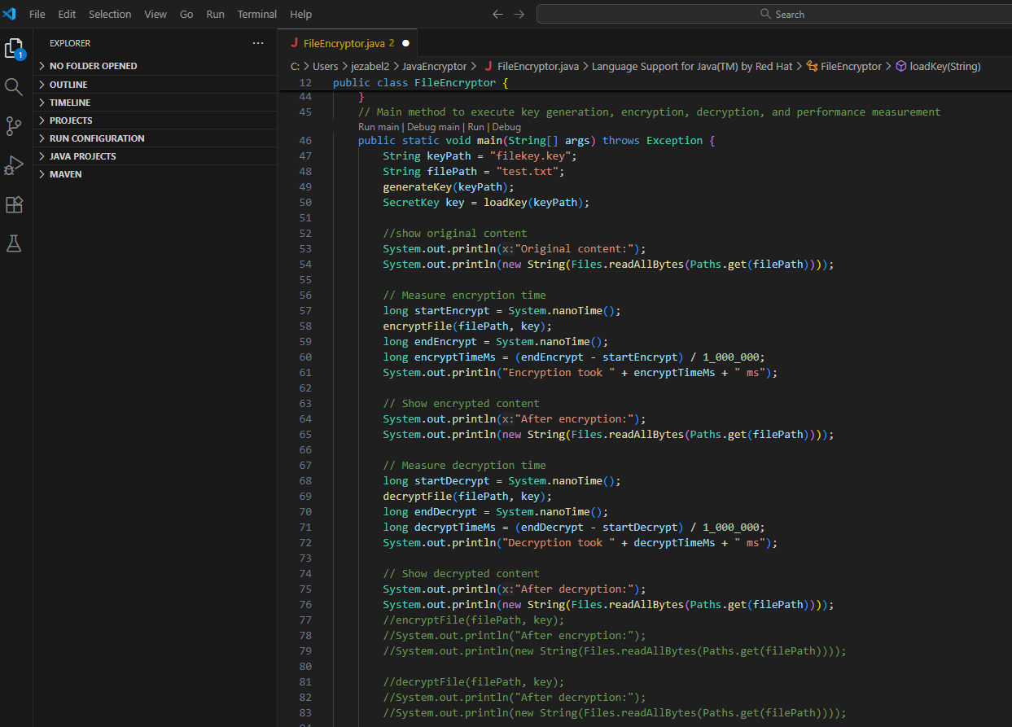

Appendix E – Troubleshooting Screenshots - Compile the Java.
Compile the program in Terminal using javac
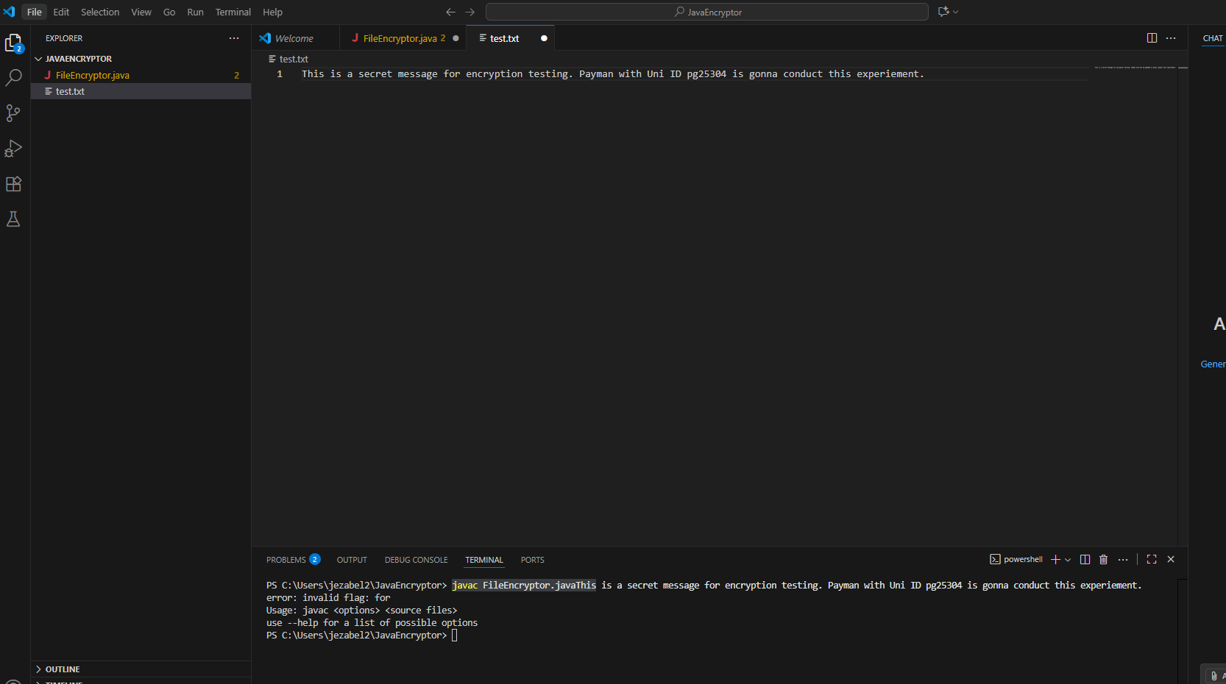

Appendix F – Continued Troubleshooting Screenshots – Runing the Java

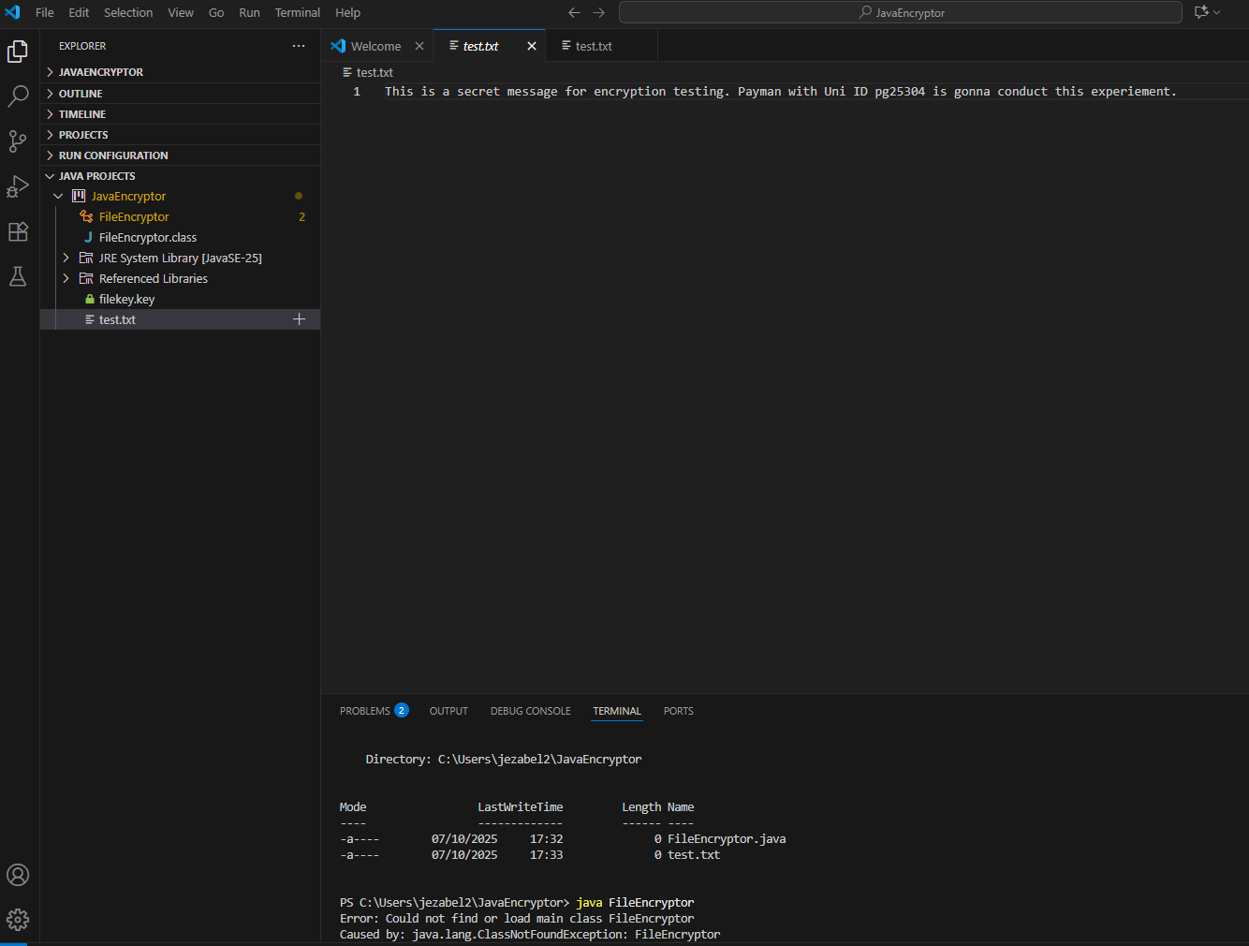
I could not Run the program, and I receive an error message as follows:
Error: could not find or load main class FileEncryptor caused by java. lang. ClassNotFoundException: FileEncryptor
I checked the directory by dir command to confirm that I am in the right folder, which I am but I could not see the FileEncryptor.class which confirm a successful compilation

Appendix F – Continued troubleshooting – Installing Hex Editor

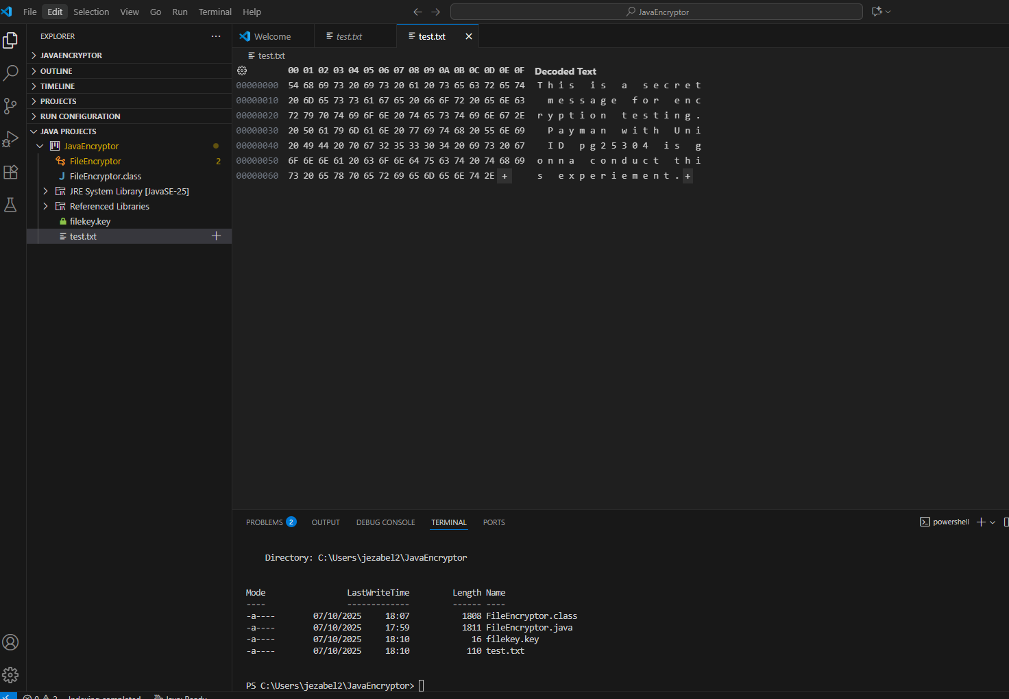
Further investigation revealed that the file content is being interpreted as plain text rather than binary.
I had to install Hex editor extension and open the test.txt with this editor to verify that the text has been encrypted

Appendix F – Troubleshooting Continued

However, I found another solution by modifying my program by adding some new lines and making several lines as comments. I Added Console Output to Show File Content in Java.
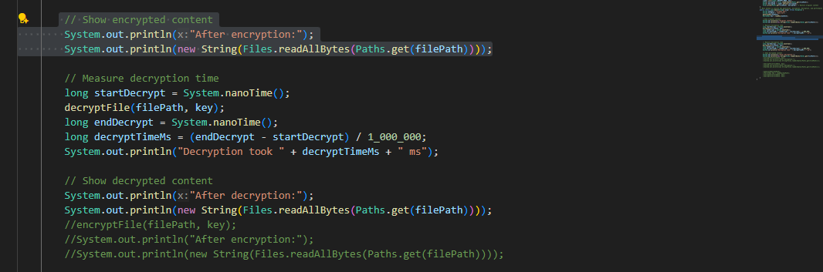
I modified the main () method to be able to verify the code directly in Terminal.
Afterwards I could see the following
Now when I run java FileEncryptor, I can see:
Original content; Encrypted content (scrambled); Decrypted content – Please refer to next page

Appendix F – Continued Troubleshooting Nanoseconds

Unfortunately, Java does not have a built-in stopwatch, but I could use System.nanoTime() to calculate how long each operation takes in nanoseconds, which you can convert to milliseconds for readability.
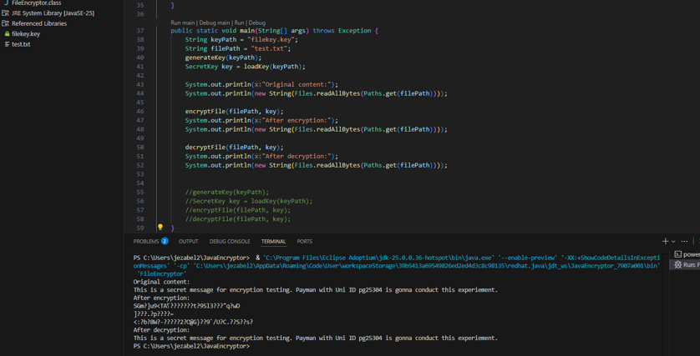

Appendix F – Continued Troubleshooting Nanoseconds

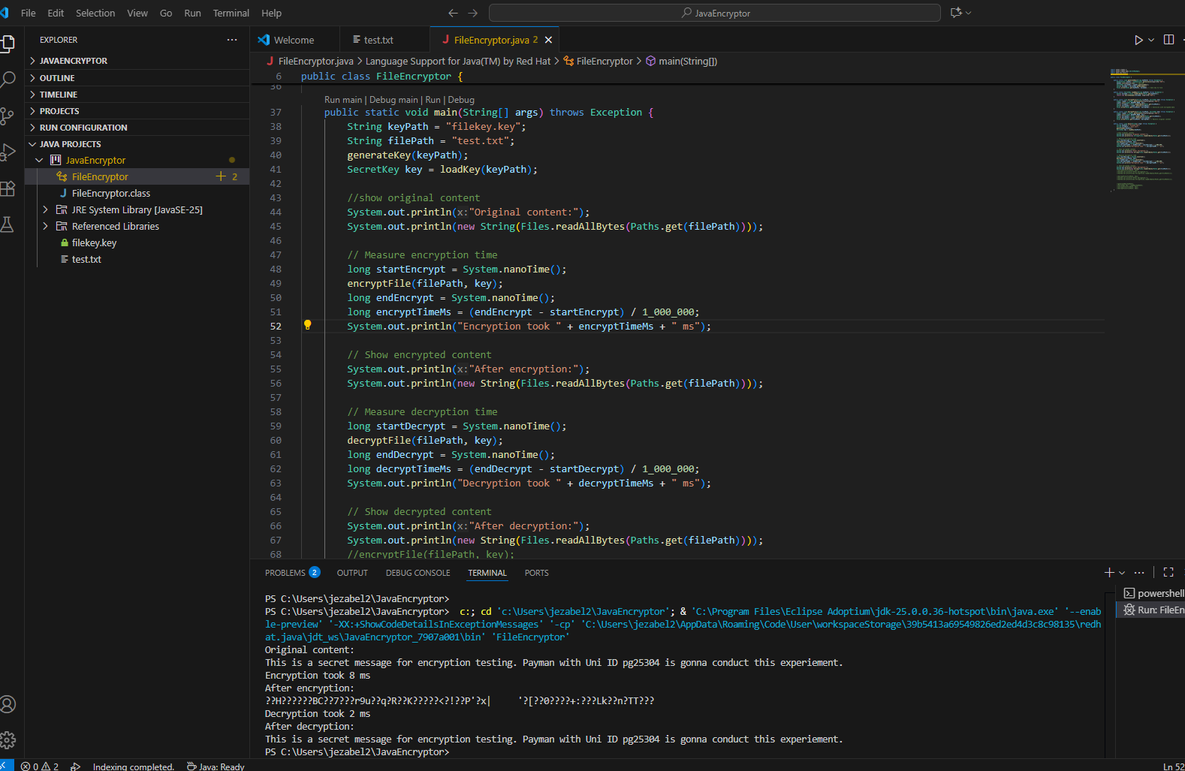

Appendix G – Java Compiled and Executed – First Time

Appendix G - Continued – Java Faster Execution (4th Run)

The Just-In-Time (JIT) compiler in Java translates bytecode that is run often into optimised native instructions after it has been interpreted for the first time. Cryptographic providers store key schedules and algorithm state in memory to lower the cost of future operations (see Georges et al., Statistically Rigorous Java Performance Evaluation, OOPSLA 2007).

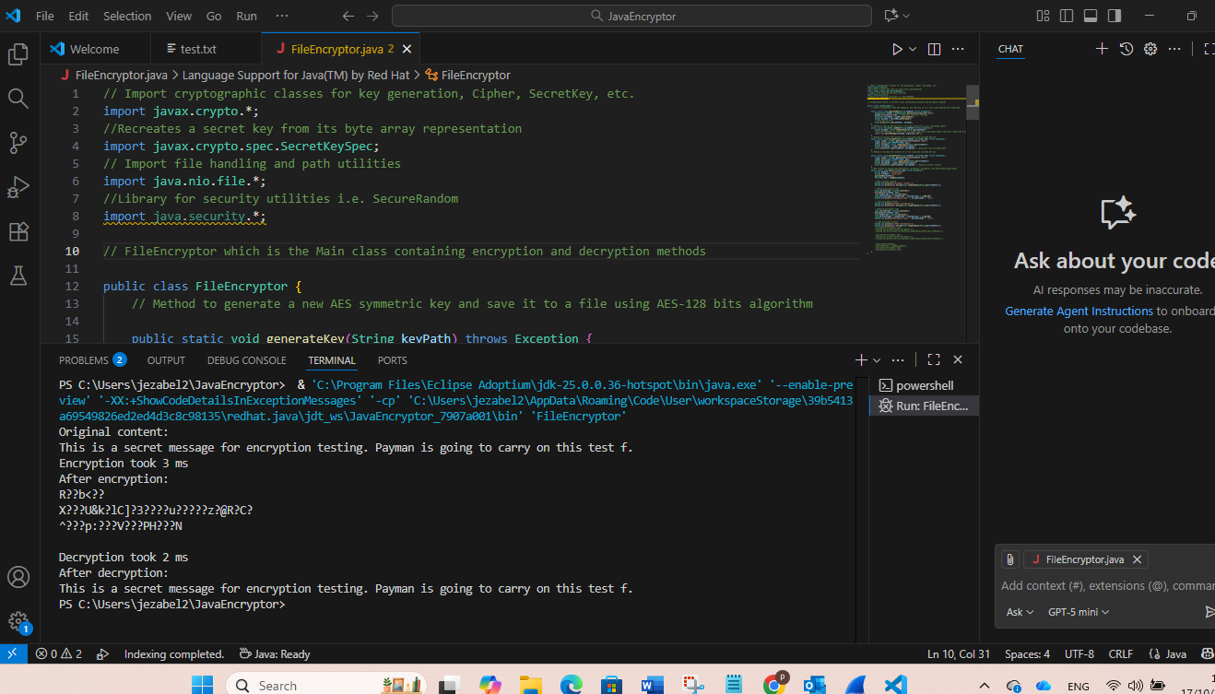

Appendix H – Development Processes and Troubleshooting Table

The table below shown development process consist of environment set up and code implementation, testing , and performance measurement. Each language presented unique challenges.
language | Environment | Testing and performance measurement (PM) | Issues and troubleshooting
Python | Jupyter Notebook with cryptography library installed via pip | Inline cells allowed for step-by-step execution and immediate feedback.  PM: Appendix I | Minimal. The main challenge was ensuring the key was reused correctly across encryption and decryption steps.  Appendices A,B, and C
Java | Visual Studio Code with OpenJDK 25 and Java Extension Pack | Required manual compilation (javac) and execution (javac FileEncryptor.java)  PM: Appendix I | Initial attempt to place project inside JDK folder caused permission concerns.  Classpath error (ClassNotFoundException) resolved by specifying current directory.  Encrypted file appeared readable in text editor; resolved by inspecting with Hex Editor.  Performance measurement required manual timing logic using System.nanoTime().  Troubleshooting:  Appendices D, E, F, and G

Appendix I – Runtime Comparison Table: Python vs Java AES Utility

Language | Task | Timing Method | Execution Time | Notes
Python | Encrypt File | %time in Jupyter | Initially 1.16ms  After four times executions reduced to: 1ms. | Fast setup, minimal overhead; ideal for prototyping, agile development, efficient for small files
Python | Decrypt File | %time in Jupyter | Initially 2ms  After Four times executions reduced to 1ms.
Java | Encrypt File | System.nanoTime() | Initially 8ms  After Four times executions reduced to 3ms. | JVM overhead; more setup required
Java | Decrypt File | System.nanoTime() | Initially 2ms  After Four times executions reduced to 2ms. | Verbose but stable; better suited for larger datasets

AES (Advanced Encryption Standard) is a symmetric encryption algorithm adopted by NIST in 2001 to replace DES. It supports key sizes of 128, 192, and 256 bits and is widely used for secure data transmission across industries.
Programming languages are organised and constructed in several various ways. Object-Oriented programming (OOP) encapsulates data, and behaviour within objects, promoting scalability, and modularity in large and complex systems. However, Procedural Programming follows a linear sequence of instructions, which is ideal for task-driven scripts. Functional Programming in contrast emphasises immutability and pure functions which well-suited for mathematical and concurrent applications. Each of them offers distinct strengths and weaknesses depending on the development context, and problem domain (GeeksforGeeks, 2023).
In Java, static means a member (variable or method) belongs to the class itself rather than to any specific object, so it can be accessed without creating an instance of the class (Oracle, 2024).
AES (Advanced Encryption Standard) is a widely used symmetric encryption algorithm due to its robustness and efficiency (Vaudenay 2002). Developed in 2001, AES supports 128, 192, and 256-bit keys, operating on 128-bit blocks (Vaudenay 2002). Its strength against various attacks contributes to its popularity.
CBC (Cipher Block Chaining) is a mode for block ciphers like AES that enhances security by introducing feedback from previous blocks, preventing patterns in plaintext and making it resistant to chosen-plaintext and chosen-ciphertext attacks (Stallings 2017).
HMAC-SHA256 is a Hash-based Message Authentication Code that combines a secret key with the SHA-256 hash function, providing data integrity and authenticity (Hintikka et al., 2017; Evans, 2019). It ensures secure communication by generating a unique, fixed-length output for message verification.
AES-GCM (Advanced Encryption Standard – Galois/Counter Mode) is a symmetric encryption algorithm that provides both confidentiality and integrity through authenticated encryption. It combines AES encryption with a cryptographic authentication tag to detect tampering.

